**Ragib Raonaq** 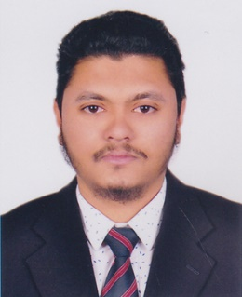

**House no-03, Road no-03,**

**Flat no-A-9, sector: 04, Uttara, Dhaka**

**Phone-01621888065**

**Email-rikterbedon88@gmail.com**

**Career Objective**

To work on a challenging job profile which provides an opportunity to enhance my technical skills & knowledge, this could provide me an insight into new aspects so that it would be helpful for my career.

**Education**

* Master in business administration (MBA) from North south university, Dhaka 2020(CGPA-3.45).
* Bachelor of Science in Electrical & Electronic Engineering (EEE) from Independent University Bangladesh, Dhaka 2019(CGPA-3.23).
* HSC in science from KAFCO School & college, Ctg 2013(GPA-4.30).
* SSC in science from KAFCO School & college, Ctg 2011(GPA-5.00).
* Elementary English course from BRITISH COUNCIL 2011 (Grade-A).

Technical Profile

* **Microsoft Office (MS word, Power Point, Excel, Internet Browsing) .**
* **Good knowledge to use PSIM, C, C++, MATLAB, Aurduino, LAB view, Autocad & Proteus.**

Interpersonal skills

* Highly developed interpersonal skills with an ability to work with multicultural & multidisciplinary teams.
* Good analytical & problem solving skills.
* Self-confident & hard working nature.
* Ability to work both independently & as a team player.

Professional Skills

* Internship trainee (3 months) from TOKAI POWER PRODUCTS LTD (Transformers, switchgear panel, PFI).

Reference

* Mizanur Rahman (Assistant Director-Ministry of Labor & Employment-Rajshahi)

Phone no-01742673617, 01711585186 email:adlmizan2312@gmail.com.

* A.M.MD Khurshid Alam (DGM Civil KAFCO fertilizer plant-ctg )

Phone: 01713161163 email:alamabu40@gmail.com